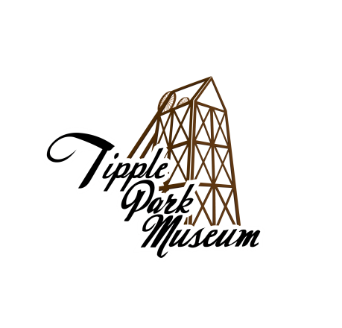

**Tipple Park Museum**

**Temporary Custody Agreement**

Donor Name: _____________________________________________________

Date Received: ___________________________________________________

Phone Number: ___________________________________________________

Email: ___________________________________________________________

Mailing Address: __________________________________________________

Number of Objects: ________________________________________________

I, _______________________________________________________________

(Donor’s Name) (Please Print)

(the “Donor”) understand that this agreement is for the consideration of the acquisition of the understated property (the “Property”) by Tipple Park Museum in

Evansburg, Alberta (the “Museum”). This offer is subject to review by the Museum before acceptance into the collection. If the Property is not accepted into the Museum Collection by the Collections Committee, *the Donor recognizes that they will be required to come and collect the Property within 90 days of receipt of notification or the Museum retains the rights to dispose of the Property as it sees fit without liability.* If the Property is accepted by The Museum, the Donor acknowledges they will need to do additional paperwork in the form of an ‘unconditional gift’ certificate, or a loan agreement.

Please read and consider the following carefully:

1. **If the Museum cannot accept all or part of the Property, would you like the Property to be returned to you?**

**___ Yes ___ No**

1. **If the Museum cannot accept all or part of the Property and you do not want the Property returned to you, do you want to waive your right to the Property and the 90-day holding period, in order to allow the Museum to dispose of the Property as it sees fit?**

**___ Yes ___ No**

Donors please retain your copy of the ‘Temporary Custody Agreement’ for return of Property if it is not accepted into the Museum Collection.

____ The Donor does acknowledge they are the rightful owner of this property and have full authority to donate this item should it be accepted as part of the Museum’s Collection. Any failure to observe the requirements of any provincial or federal laws or regulations, from any misrepresentation by the Donor pertaining to the Donor's ownership of the Property and the history of the Property, and from any claims of third parties claiming an interest in the Property, shall be indemnified by the Donor.

____The Donor represents that the Donor is the owner of all copyright interests, including moral rights, in the Property (if applicable).

____ The Donor has completed the History of Property section of this agreement. The Donor represents that the history provided is true and accurate to the best of the Donor’s knowledge and belief. The Donor warrants that the Donor has complied with all laws of the Province of Alberta and Canada and applicable international conventions and treaties.

____ The Donor warrants that the Property is free of all liens and encumbrances, including without limitation any claims of any taxing authority.

**DESCRIPTION OF PROPERTY**

(Name of object(s), physical identifiers; please list)

|  |  |  |  |  |
| --- | --- | --- | --- | --- |
|  |  |  |  |  |
|  |  |  |  |  |
|  |  |  |  |  |
|  |  |  |  |  |
|  |  |  |  |  |
|  |  |  |  |  |
|  |  |  |  |  |

|  |  |  |  |  |
| --- | --- | --- | --- | --- |
|  |  |  |  |  |
|  |  |  |  |  |
|  |  |  |  |  |
|  |  |  |  |  |
|  |  |  |  |  |
|  |  |  |  |  |
|  |  |  |  |  |

**HISTORY OF PROPERTY**

All information about the history of an artifact or document is extremely helpful.The context from which these items originate helps us understand the history of the item, as well as the history of the individuals/community connected to the item. Understanding the context of historical items helps facilitate future research and education and preserves the culture and history of the Evansburg/Entwistle community.

1. **Where did the item originate? List the creator/artist, date, and place of creation if known.**

__________________________________________________________________________________________________________________________________________________________________________________________________________________________________________________________________________________________________________________________________________________________________

1. **Who was the first to own/use/display the item? Who owned/used it subsequently? Was it owned/used/displayed in the Evansburg/Entwistle area originally or later?**

__________________________________________________________________________________________________________________________________________________________________________________________________________________________________________________________________________________________________________________________________________________________________

1. **Are there any stories relating to the item?**

__________________________________________________________________________________________________________________________________________________________________________________________________________________________________________________________________________________________________________________________________________________________________

1. **Why is the item important to the Evansburg/Entwistle area?**

__________________________________________________________________________________________________________________________________________________________________________________________________________________________________________________________________________________________________________________________________________________________________

_____________________________ ___________________________

Donor Signature Museum Representative

_____________________________ ___________________________

Date Date

_____________________________ ___________________________

Printed Name of Donor Printed Name of Representative

_____________________________

Title

(if representing an institution, corporation, or other legal entity)

**Collection Committee Only**

Accepted ___ Declined ____ by Collection Committee on __________________

(Date)

Donor notified by:

| **Method** | **Date** | **Museum Representative** |
| --- | --- | --- |
| Letter |  |  |
| Email |  |  |
| Phone |  |  |
| Mail |  |  |

**Questions to Consider in Regards to Giving a Complete History of Property:**

(We do not need this sheet returned; this is simply a prompt list on the information that is useful/relevant for items in our collection. Some questions may not be applicable depending on the nature of the donation.)

1. Are all the pieces/objects being donated part of a related or shared history? (i.e a set or collection of porcelain teacups collected by a family member)
   1. If they are separate, please consider all these questions for each Object. Feel free to write more information on the back of these sheets or on a separate piece of paper (just make sure you put your name in the top right-hand corner so we can make sure it stays with the right paperwork)
2. Who owned the object(s)? Did it pass through multiple hands over the years? How did it come into your possession if it was not originally owned by the Donor?
3. When was the object(s) purchased or originally made? Was it brought to the area when someone moved here? If so, from where?
4. What was the object used for? What was the purpose it served?
5. Is there a specific event associated with the object(s)? (i.e. a festival, family function, historic event, etc…)
6. Is it linked to a business, community group, or specific location?
7. If the donation is **a photo or paper document**; who is the Object about? Where was it taken? For what purpose? Is there a specific story this image/document is reflective of (i.e. a family vacation, a wedding, receipts reflecting the cost of an item back in 1936, etc…)